Lectures 6 & 7 - Relational Algebra (Basics & Advanced)
Objective: To research, understand, and present a specific set of relational algebra operations, demonstrating their syntax, use cases, and relationship to SQL.
- Presentation time: 10-12 minutes per group.
- Visual aids: Create clear and professional slides (PowerPoint, Google Slides, Canva, etc.).
Group 1 | Bakhytbekkyzy Aiym  Atymtai Asylzat  Kanatkyzy Asylai  Kim Oleg
Group 2 | Abdullauly Isatay  Abuov Aslan  Mamyrkhan Aslan  Kuanyshbek Bagdat
Group 3 | Timur Klyshbekov  Zhamaladin Nurimseit  Mairamov Madiar  Dairabay Nurdaulet
Group 4 | Сарыбаев Алихан  Утепберген Мади  Оразбек Еламан  Болатбек Иса
Group 5 | Крестников Никита  Фоменко Андрей  Арапбай Арафат  Ким Руслан

Key components:
1. Introduction: Briefly define the operation(s) and their purpose.
2. Syntax & explanation: Show the formal relational algebra notation.
3. Example: Use the provided University database schema (below) to illustrate your operation(s). Show the "before" and "after" tables (the resulting relation).
4. SQL Connection: For each operation, show the equivalent SQL query.
5. Conclusion: Summarize the importance of your assigned operations.
Schema for all examples:
- Students
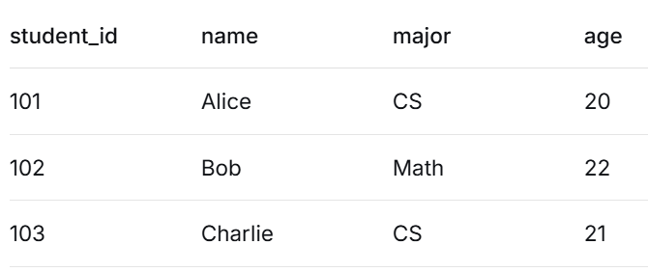
- Courses
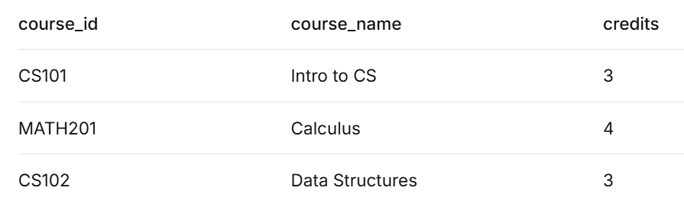
- Enrollments (connects Students and Courses)
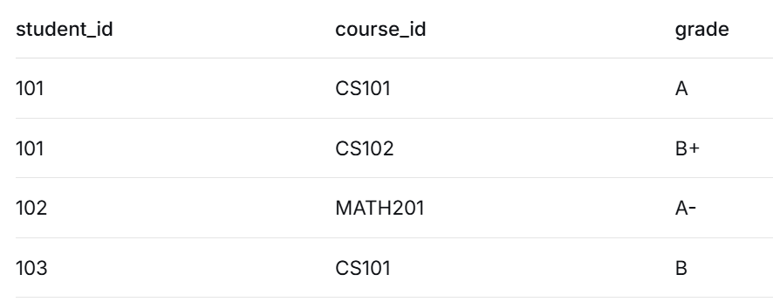

GROUP ASSIGNMENTS
Group 1: The fundamentals - selection & projection
- Explain the difference between selecting rows (Selection) and selecting columns (Projection).
- Show the notation for conditions in Selection
- Examples:
1. Select all students who are CS majors.
2. Project only the names and majors of all students.
3. Combine them: Find the names of all CS majors.
- SQL: Show the «SELECT * WHERE ...» and «SELECT ... FROM ...» queries for your examples.

Group 2: Set operations - union, intersection, difference
- Explain the crucial rule for these operations: Union Compatibility (same number of attributes and compatible data types).
- Examples: You will need to create a second small table, e.g., Instructors («instructor_id», «name», «dept», «age»).
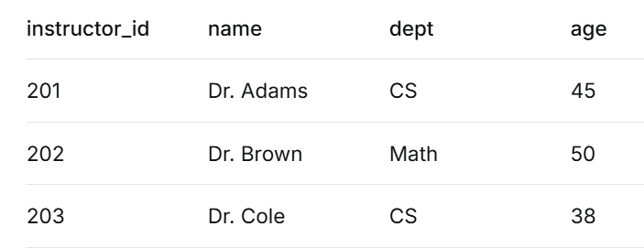
- Using the «Students» and «Instructors» tables (projecting to «name», «age» to ensure compatibility), demonstrate:
1. Union («Students ∪ Instructors»): Find all names and ages of people in the university (students and instructors).
2. Intersection («Students ∩ Instructors»): Find people who are both a student and an instructor (by name and age).
3. Difference («Students − Instructors»): Find people who are students but not instructors.
- SQL: Show how «UNION», «INTERSECT», and «EXCEPT» (or «MINUS») are used.

Group 3: The power of combination - cartesian product & rename
- Explain the Cartesian Product (combining every row from one table with every row from another). Discuss its potential for creating huge, meaningless results and why it's usually followed by a Selection.
- Explain the Rename operation and why it's essential (to avoid naming conflicts, especially with Cartesian Product and self-joins).
- Examples:
1. Show the Cartesian Product of «Students» and «Enrollments» («Students × Enrollments»). Point out the duplicate attribute names (e.g., «student_id» from both tables).
2. Use the Rename operation to disambiguate attributes.
3. Show a meaningful query: "Find the names of students and the courses they are enrolled in." This requires a Cartesian Product followed by a Selection to match the «student_id»s, followed by a Projection
- SQL: Show the equivalent query using a «JOIN» (or a «CROSS JOIN» for the product) and a «WHERE» clause for the join condition.

Group 4: Bringing tables together - inner & outer joins
- Explain that a Join is a shorthand for a Cartesian Product followed by a Selection.
- Inner Join: Show a natural join between «Students» and «Enrollments». What happens to student 103 (Charlie) who is not enrolled? Explain that inner joins only show matching rows.
- Outer Joins: Use the «Students» and «Enrollments» tables to demonstrate:
1. Left Outer Join: Show all students, even if they have no enrollments. (Charlie should appear with «NULL» values for course/grade).
2. Right Outer Join: Show all enrollments, even if the student info is missing (not applicable in this specific data).
3. Full Outer Join: Show all rows from both tables, matching where possible.
- SQL: Show the SQL equivalents: «INNER JOIN ... ON ...», «LEFT JOIN», «RIGHT JOIN», «FULL OUTER JOIN».

Group 5: The advanced query - the division operation & sql example
- Division: Explain that Division is for queries that ask "for all" or "which X are associated with all Y?"
- Example Query: "Find the names of students who are enrolled in all courses offered by the CS department."
1. First, create a relation of all CS courses (Courses table doesn't have a department, so assume «Courses» has a «dept» attribute for this example).
2. Then, find the pairs of «student_id» and «course_id» from Enrollments
3. The Division operation: «Qualified_Students = Student_Courses ÷ CS_Courses». This gives you the «student_id»s who are enrolled in every CS course.
4. Finally, join with «Students» to get the names
- Walk through the division process step-by-step. It's complex, so a clear, visual explanation is key.
- SQL: Show the complete SQL query for this problem. It will likely involve a «GROUP BY», «HAVING», and subqueries or a double «NOT EXISTS» clause. Explain how the SQL achieves the same result as the division operator. This demonstrates how a complex relational algebra operation translates into a real-world SQL query.

